Project Design Phase
Solution Architecture
Date | 13 July 2026
Team ID
Project Name | Voice-Based Concept Understanding Analyzer (VBCUA)
Maximum Marks | 4 Marks
Solution Architecture:
Solution architecture is a complex process – with many sub-processes – that bridges the gap between business problems and technology solutions. Its goals are to:
- Find the best tech solution to solve existing business problems.
- Describe the structure, characteristics, behaviour, and other aspects of the software to project stakeholders.
- Define features, development phases, and solution requirements.
- Provide specifications according to which the solution is defined, managed, and delivered.
Solution Architecture Diagram: VBCUA
The diagram below shows the actual architecture and data flow implemented for VBCUA: the user interacts with a local Streamlit web interface, which passes the uploaded audio through a sequential pipeline of processing modules (transcription, semantic analysis, scoring, and report generation), each reading from or writing to local file storage.
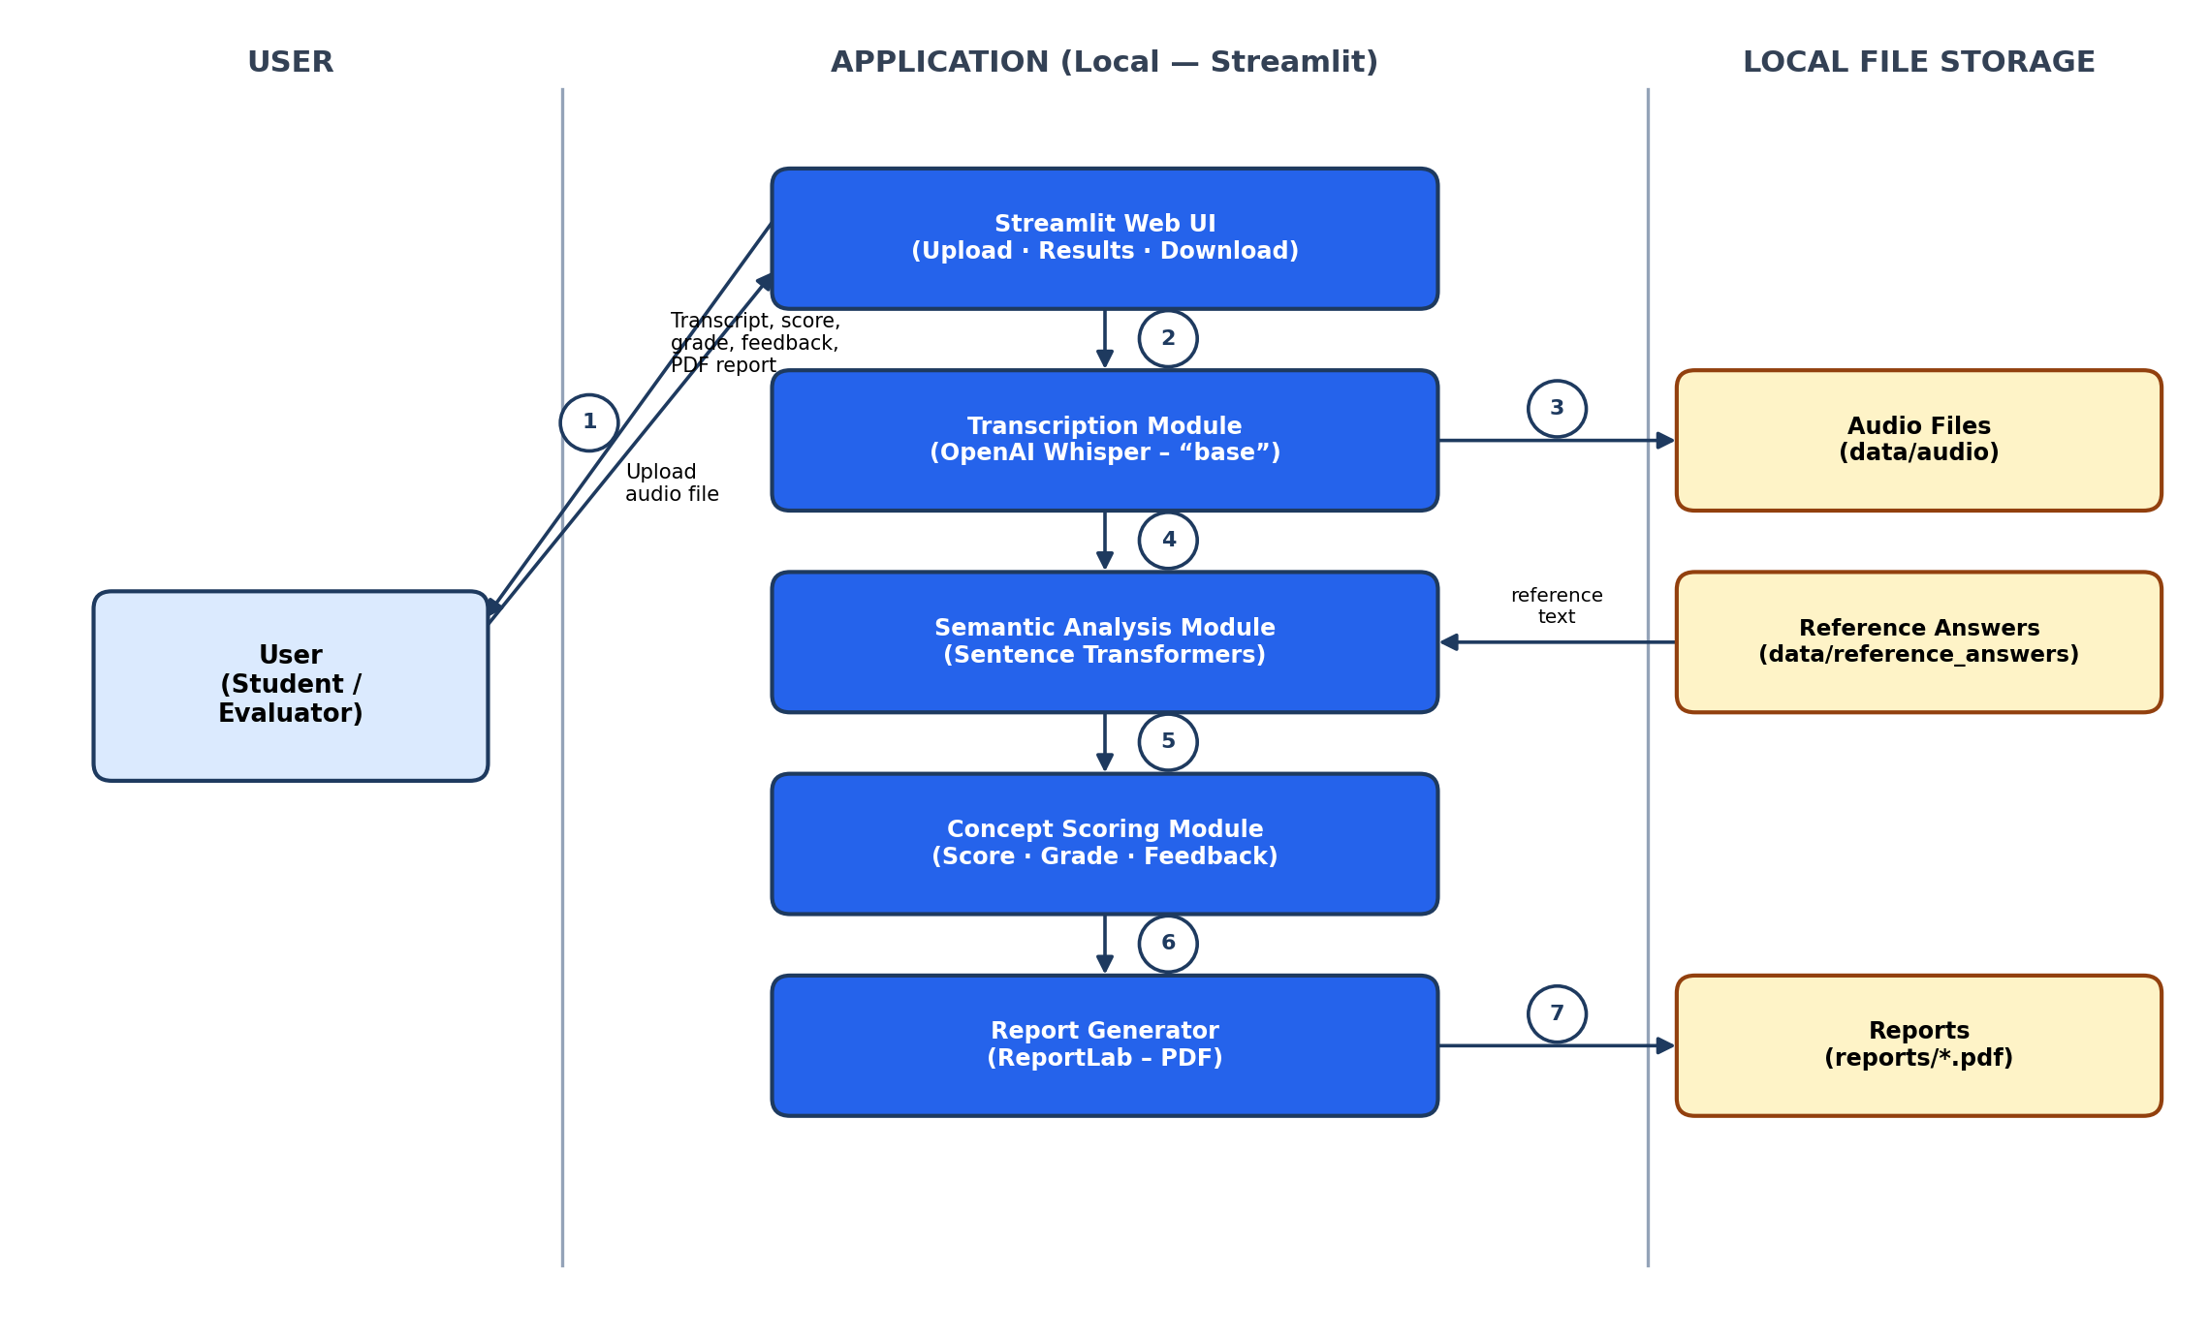
Figure 1: Architecture and data flow of the Voice-Based Concept Understanding Analyzer (VBCUA)

